Science
We will be learning about habitats, deforestation and its impact on animals, as well as food chains. We will also be looking at the digestive system and how diet is used to fuel animals in different ways. We will continue to look at different ways to collect and process data through our data collection unit.

P.E.
This term, we will have Forest Schools with Mrs Palmer, on Friday afternoons. Children will need to wear suitable clothes to be outdoors in variable weather (see newsletter).
The second PE session will be on Monday afternoons, so all children will need to arrive in their PE kit for that session.

Art
We will be looking at how to create increasingly complex mono prints, taking inspiration from the work of Sue Brown. We will recap how to make prints (as well as some of the techniques that did and did not work from last time) and then look at how we can use layering and colour to make more complex designs.

Music
This term, Mr Courtney will be preparing the children for an in-school performance. We will not be attending WCET this year. Further details about the performance and how families can attend will be shared closer to the time.

History
In our unit, we will be trying to answer the question ‘How hard was it to invade and settle in Britain?’. In this unit, we will be exploring who the invaders were and some of the reasons for them coming to the British Isles, as well as the impact that they had on our society and how they fit into to our chronological understanding of history.

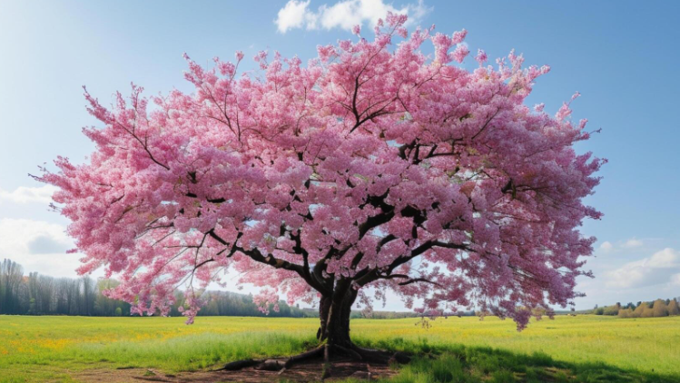
R.E.
We will be exploring the following questions:

Do people need to go to church to show they are Christians?

What motivates Humanists to lead a good life?

English
This term we will be reading ‘Georges Marvellous medicine’ in Destination Reader. In Writing, we will be continuing to build on our understanding of grammar and spelling rules through the context of newspaper recounts, non-chronological reports, and developing our character descriptions through narrative. Book focuses are ‘Leon and the place between’ and ‘Arthur and the golden rope.’
Geography
After half term, we will answer the question ‘What are rivers and how are they used?’ This will include exploring one of our local rivers and water ways.

What Cherry Class are doing this term
Summer 2026
Maths
This term, we will be looking at telling the time, statistics and shapes and angles.
ICT
We will be sequencing sounds through the use of computing software. We will also be exploring issues around their ‘online reputation’ and how to make sure that they are fostering a positive one.

